Ser/Des Driver Safety Case

In Compliance with ISO 26262
Document Title: | Safety Case
Project Identifier:
Project Target Release:
Project Short Description:
Document Owner: | Heba Safwat
Document Responsibility: | Brightskies
Document Version: | 1.0
Document Classification: | Confidential
Document Status: | Draft
Document Archive:

Table of Contents
Copyright 4
Document Approval Record 4
Document Revision History 4
Review and Approval 4
Confirmation review 4
Version Review 5
Abbreviations 5
1. Introduction 6
2. Scope 6
3. Use of Goal Structured Notations (GSN) 6
4. Ser/Des Driver Qualification process 7
5. Limitation 7
6. Safety Claims 7
6.1 Top Level Safety Claim 8
6.2 Organization Safety Management Capability Claim 9
6.2.1 Safety claim of resources competency 10
6.2.2 Safety claim of organization maturity 10
6.2.3 Safety claim of tools confidence level 11
6.3 Ser/Des Driver Identification Completion Claim 11
6.3.1 Safety claim of the safety plan execution and deliverables completion 12
6.3.2 Safety claim of the safety plan coverage for the component identification activities and deliverables 13
6.4 Ser/Des Driver Safety Acceptance Claim 15
6.4.1 Safety claim of the safety plan execution and deliverables completion 16
6.4.2 Safety claim of the safety plan coverage for the component safety qualification activities and deliverables 17
7. Safety Case Process Compliance 19

Tables
Table 1: Revision History 4
Table 2: Confirmation review 4
Table 3: Version Review 5
Table 4: List of abbreviations 5
Table 5: Solutions of Safety Management Capability Claim 11
Table 6: Solutions of component identification Claim 14
Table 7: Solutions of Component safety qualification Claim 18
Table 8: Qualification Process Work Products 19

Figures
Figure 1: Top Level Safety Claim 8
Figure 2: Organization safety management capability claim 9
Figure 3: Resources competency claim 10
Figure 4: Organization maturity claim 10
Figure 5: Tools Integrity Claim 11
Figure 6: Ser/Des Driver Identification Claim 12
Figure 7: Safety Plan Execution Claim 12
Figure 8: Ser/Des Driver Activities and Deliverables Claim 13
Figure 9: Ser/Des Driver Safety Qualification Claim 15
Figure 10: Safety Plan Execution Claim 16
Figure 11: Safety analysis and safety mechanisms implementation claim 17
Figure 12: Unit Testing Completion Claim 17
Figure 13: Code Compliance with SW Quality Measures Claim 18

Copyright

Reproduction or utilization of any part of this document by any means, including photocopying and microfilm, without permission in writing by Brightskies is strictly forbidden.

Document Approval Record

This safety case is to be approved by the following competency representatives. If no response to the request for review and approval is received by the due date, it will be considered “approved”

Document Revision History
Revision No. | Revision Date | Author | Description
0.1 | 25/03/2026 | Heba Safwat | Initial Version
0.2 | 17/06/2026 | Heba Safwat | Delete the activities (Safety manual and Code Verification Report)

Table 1: Revision History

Review and Approval
This Safety Case Argument is reviewed and approved by the following:
- The Global Functional Safety Manager
- Confirmation review team

Confirmation review
Review Scope | Project ASIL | Reviewer (s) Name | Independence requirement | Review completion Date
Documentation completeness of the Safety Case report
Table 2: Confirmation review

Version Review
Version Reviewed | Reviewer Role | Reviewer Name | Approval Date | Note
0.1 | Global Functional Safety Manager
0.1 | Global Functional Safety Manager
Table 3: Version Review

Abbreviations
Explanation of used abbreviations
Abbreviation | Explanation
ASIL | Automotive Safety Integrity Level
FSM | Functional Safety Management (or Manager)
CDD | Component Design Document
BSS | BrightSkies
SW | Software
FMEA | Failure Modes and Effects Analysis
WP | Work Product
Table 4: List of abbreviations

- Introduction
The goal of a safety case is to provide a structured argument, supported by evidence, to justify that a system is acceptably safe following a specific assumptions of use in a specific operating environment. The evidence is compiled through the work products generated during the lifecycle.
As such, a safety case report shows by evidence that all hazards are mitigated by safety requirements and that these requirements are implemented and verified. It documents that the safety requirements for an item or element are complete and satisfied, the required functional safety activities have been performed, and the required deliverables are produced and verified to be acceptable.
- Scope
This safety case is developed for MEKRA Ser/Des Driver qualification processes to ASIL-B component in compliance with ISO 26262-8:2018 clause 12. It will cover all activities and deliverables executed for the qualification of the component. All the component qualification activities and deliverables will be executed by Brightskies.
Any future changes/modifications occur to the component in scope, appropriate updates to the existing safety case shall be made
- Use of Goal Structured Notations (GSN)
The Goal Structured Notation (GSN) was applied to compile the safety case for the Ser/Des Driver. The following arguments were prepared:
- Argument of the Ser/Des Driver identification in compliance with ISO 26262:2018, that is supported by the component design document and confirmation measures report.
- Argument of the Ser/Des Driver safety acceptance in compliance with ISO 26262:2018, that is supported by Safety analysis, Safety requirements, Safety mechanisms implementation, and testing.
- Argument of organization safety management capability, which is supported by competency report, and quality certificates.
Following establishment of these arguments, the safety case work products are presented at the end of this report.

- Ser/Des Driver Qualification process
The main purpose of this document is to ensure the execution of all activities and deliverables at the qualification processes in compliance with ISO 26262-8:2018 clause 12, and this can be done by
- Confirm the identification of Ser/Des Driver
- Provide evidence for the compliance of the component with its identified requirement.
- Provide evidence for the suitability of the component with its intended use.
- Confirm the completion of all the qualification work products
- Provide the argument and evidence for the executed activities and delivered work products compliance with ISO 26262-8:2018 clause 12
- Limitation
No significant limitations exist.
- Safety Claims
The goal of this safety case report is to provide a structured argument, supported by evidence, to justify that the Ser/Des Driver developed by MEKRA is a qualified ASIL-B component as per ISO 26262-8:2018 clause 12.
Argumentation schema is presented using the GSN community standard. The associated evidence complements this argumentation.

GSN defines the following elements that will be used in this safety case:
- Goals – Gx
A goal, rendered as a rectangle, presents a claim forming part of the argument.
- Strategies – Sx
A strategy, rendered as a parallelogram, describes the nature of the inference that exists between a goal and its supporting goal(s).
- Solutions – Sn
A solution, rendered as a circle, presents a reference to an evidence item or items.
- Contexts - Cx
A context, rendered as shown left, presents a contextual artefact. This can be a reference to contextual information, or a statement.

Top Level Safety Claim
The top level safety claim is that the Ser/Des Driver component was qualified as ASIL-B component available for usage in safety related applications. The claim is supported by strategies and goals executed in compliance with ISO26262-8:2018 clause 12 explored further in this report.
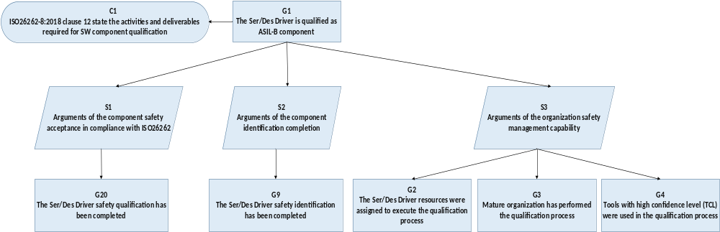
Figure 1: Top Level Safety Claim

Organization Safety Management Capability Claim
Claim of BSS safety management capability is based on the following proven claims:
- The resources assigned to the project demonstrates a high level of competency and expertise which ensures the quality of the qualification activities and work products.
- BSS has a clear safety culture and a reliable quality management system.
- Tools used at critical activities in the qualification process have high level of integrity.
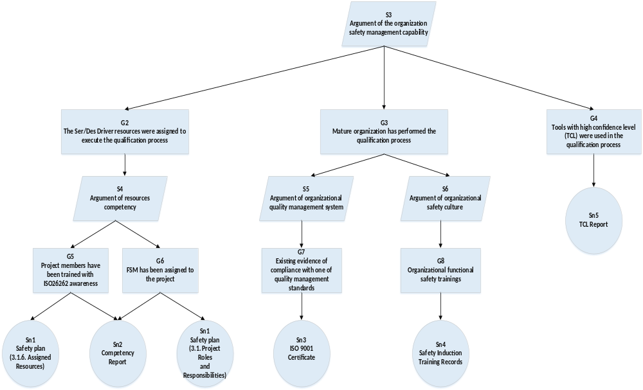
Figure 2: Organization safety management capability claim

6.2.1 Safety claim of resources competency
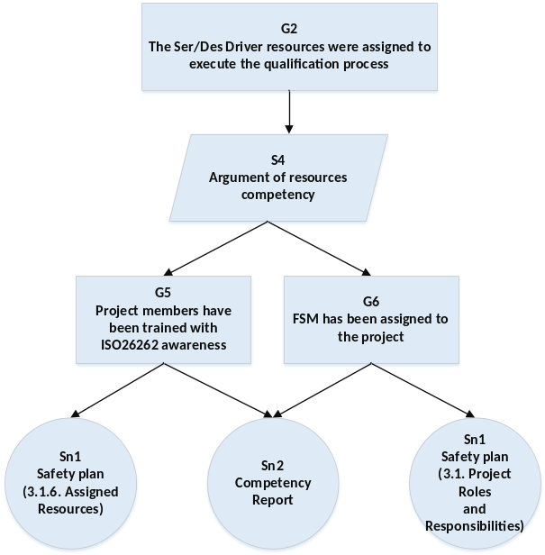
Figure 3: Resources competency claim

Safety claim of organization maturity
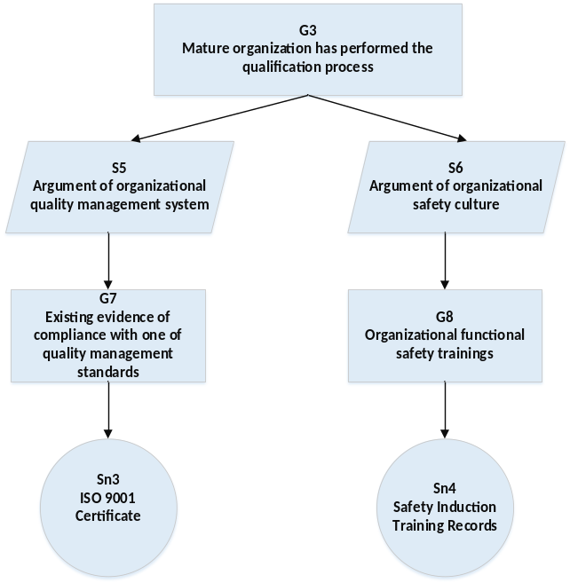
Figure 4: Organization maturity claim

Safety claim of tools confidence level

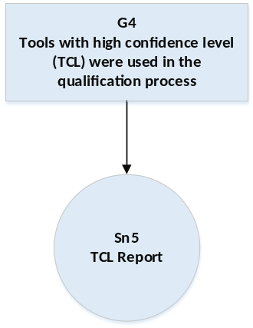
Figure 5: Tools Integrity Claim
Solution Number (Sn) | (Documents) | Work Product Number (WP)
Sn1 | Safety Plan | WP_1
Sn2 | Competency Report | WP_2
Sn3 | ISO 9001 Certificate | -
Sn4 | Safety Induction Training Records | -
Sn5 | TCL Report | WP_3
Table 5: Solutions of Safety Management Capability Claim

Ser/Des Driver Identification Completion Claim
The component identification claim is that the Ser/Des driver component was identified in compliance with ISO26262-8:2018 clause 12 by the execution of safety plan activities which include the component identification, description, requirements of the intended use, configuration, interfaces, and shared resources.
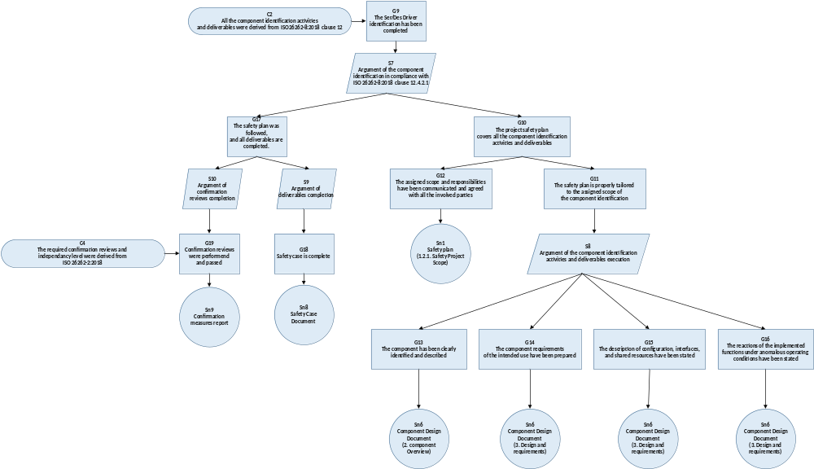
Figure 6: Ser/Des Driver Identification Claim

Safety claim of the safety plan execution and deliverables completion
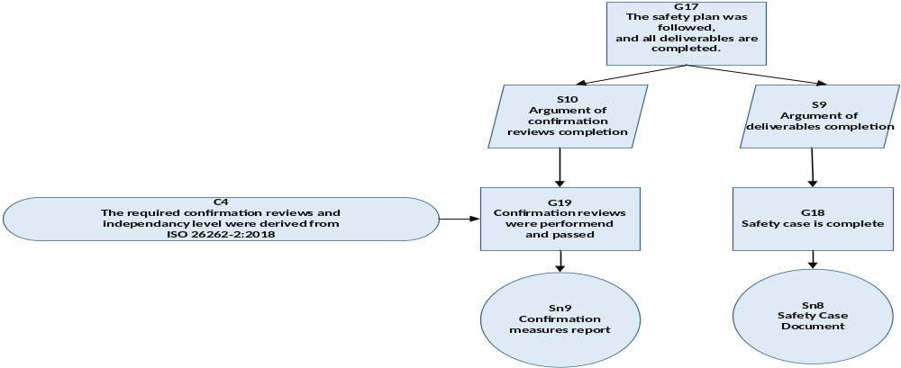
Figure 7: Safety Plan Execution Claim

Safety claim of the safety plan coverage for the component identification activities and deliverables
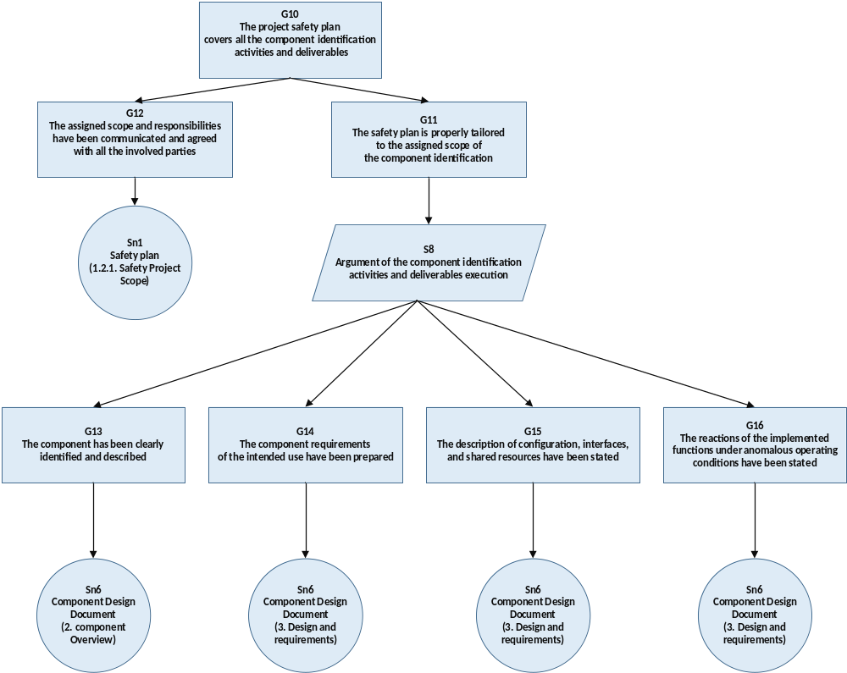
Figure 8: Ser/Des Driver Activities and Deliverables Claim
Solution Number (Sn) | (Documents) | Work Product Number (WP)
Sn1 | Safety Plan | WP_1
Sn6 | Component Design Document | WP_4
Sn8 | Safety Case Document | WP_6
Sn9 | Confirmation Measures Report  (Safety Analysis) | WP_7
Sn9 | Confirmation Measures Report  (Safety Case) | WP_17
Sn9 | Confirmation Measures Report  (Safety Plan) | WP_18
Table 6: Solutions of component identification Claim

Ser/Des Driver Safety Acceptance Claim
The component safety acceptance claim is that the Ser/Des Driver component safety qualification was made in compliance with ISO26262-8:2018 clause 12 by the execution of safety plan activities which include the following activities: SW FMEA, Safety Mechanisms Implementation, Static Analysis, Code inspection, Code implementation following SW quality metrics, and unit testing.
Unit testing activities were executed following the test plan in compliance with the required test activities for ASIL-B component qualification.
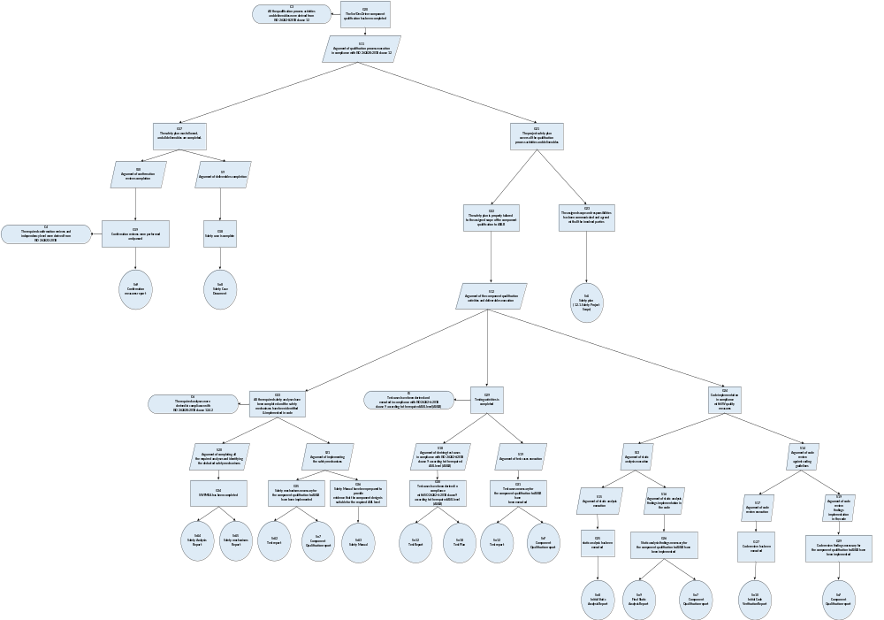
Figure 9: Ser/Des Driver Safety Qualification Claim

Safety claim of the safety plan execution and deliverables completion
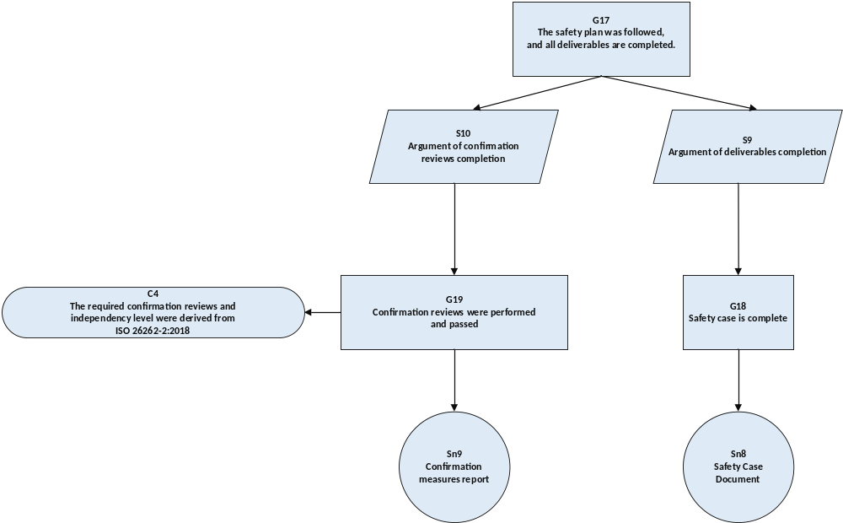
Figure 10: Safety Plan Execution Claim

Safety claim of the safety plan coverage for the component safety qualification activities and deliverables

Safety claim of the safety analysis completion and safety mechanisms implementation in code
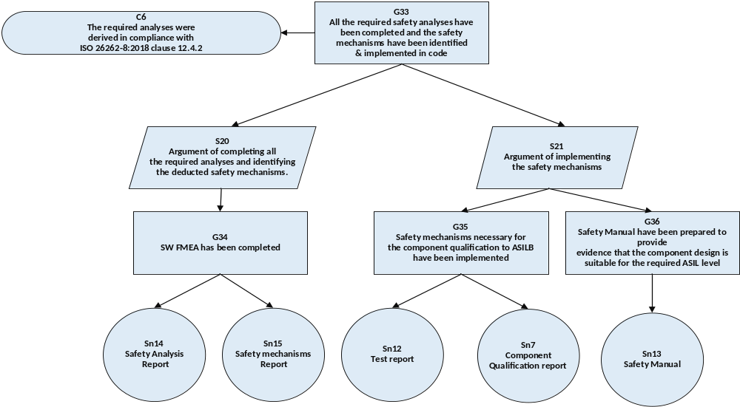
Figure 11: Safety analysis and safety mechanisms implementation claim

Safety claim of the testing activities completion
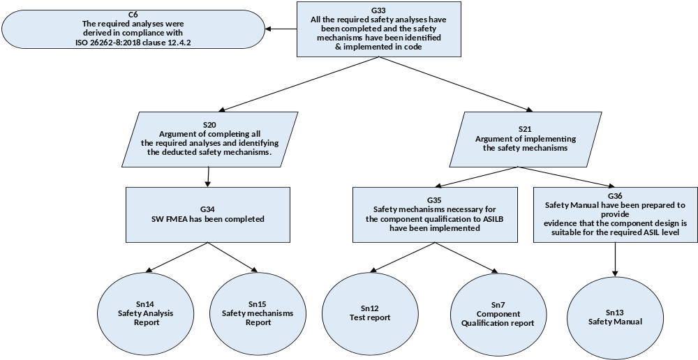
Figure 12: Unit Testing Completion Claim

Safety claim of the final code compliance with SW quality measures

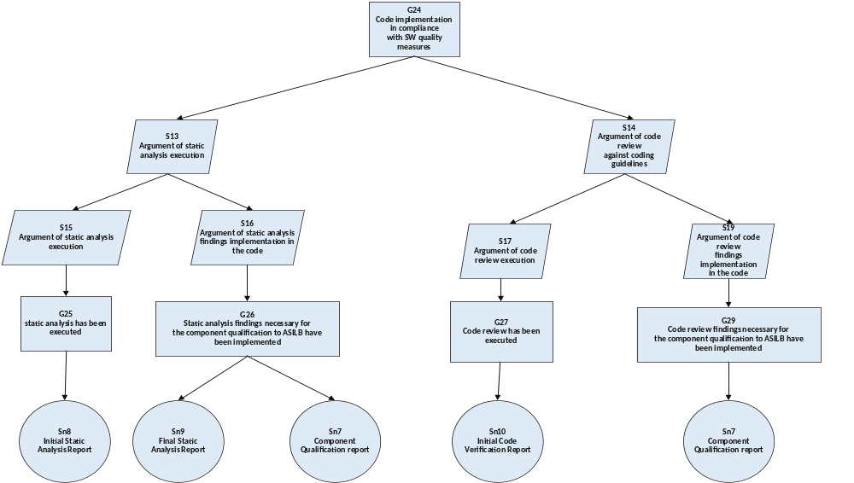
Figure 13: Code Compliance with SW Quality Measures Claim
Solution Number (Sn) | (Documents) | Work Product Number (WP)
Sn1 | Safety Plan | WP_1
Sn7 | Component Qualification Report | WP_5
Sn8 | Safety Case Document | WP_6
Sn9 | Confirmation Measures Report | WP_7
Sn12 | Test Report | WP_10
Sn14 | Safety Analysis Report | WP_12
Sn15 | SW Safety Requirements | WP_13
Sn17 | Static Analysis Report | WP_15
Sn18 | Test Plan | WP_16
Table 7: Solutions of Component safety qualification Claim
- Safety Case Process Compliance
This section lists all the WP prepared at the qualification processes in compliance with ISO 26262-8:2018 clause 12.

WP_ID | Work Product | Responsibility | Status | Link
WP_6 | Safety Plan | BSS (FuSa Team) | Final | 06. Safety_Plan_MVC_SerDes_Driver_Rev_0.2.docx
WP_2 | Competency Report | BSS (FuSa Team) | Final
WP_1 | TCL Report | BSS (FuSa Team) | Final | 01. TCL_Report_MEKRA_Rev0.1.xlsx
WP_4 | Component Design Document | BSS (SW Dev Team) | Final
WP_4 | Component Qualification Report | BSS (FuSa Team) | Final | 04. Qualification_Report_MEKRA_SerDes_Rev.01.docx
WP_2 | Safety Case Document | BSS (FuSa Team) | Final | 02. Safety_Case_MEKRA_SerDesDriver_Rev_0.1.docx
WP_7 | Confirmation Measures Report  (Safety Analysis) | BSS (FuSa Team) | Final
WP_17 | Confirmation Measures Report  (Safety Case) | BSS (FuSa Team) | Final
WP_18 | Confirmation Measures Report  (Safety Plan) | BSS (FuSa Team) | Final
WP_10 | Test Report | BSS (SW Test Team) | Final
WP_3 | Safety Analysis Report | BSS (FuSa Team) | Final | 03. fmea_SOW_2.xlsx
WP_5 | SW Safety Requirements | BSS (FuSa Team) | Final | 05. Safety_Mechanisms_Report_SerDes_Rev_0.1.xlsx
WP_15 | Static Analysis Report | BSS (SW Dev Team) | Final
WP_16 | Test Plan | BSS (SW Test Team) | Final
Table 8: Qualification Process Work Products

